Propensity Score-Based Methods for Causal Inference

Module 1: The concept of potential outcomes

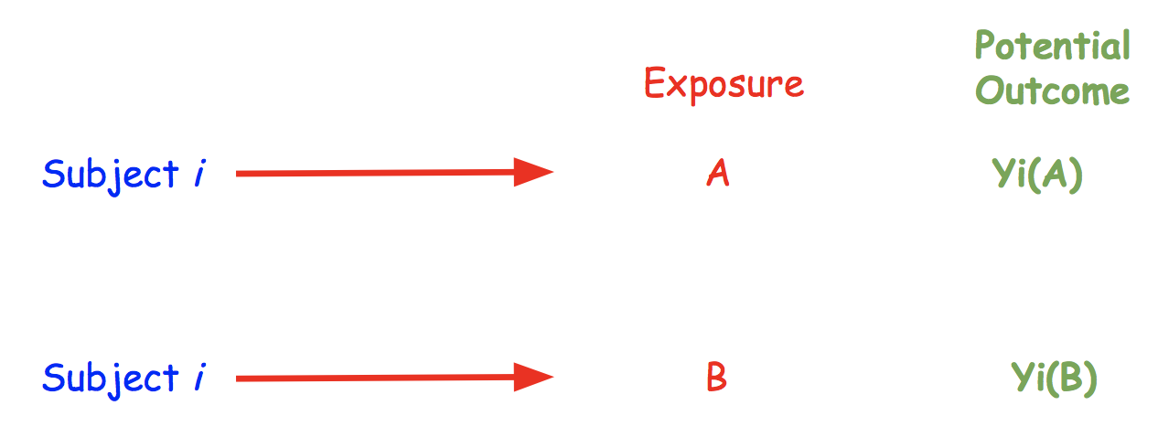

**I. Module Objectives**

Determining what do we mean by a “causal effect” requires some underlying framework for causal inference. One such framework is the “potential outcomes framework”.

The basic idea of potential outcomes is that a given subject can experience different outcomes under different treatments, interventions, or exposures. One of those outcomes can be observed; the others are referred to as counterfactual outcomes. To assess the causal effect, we wish to evaluate, for the same subject under identical conditions, whether there is an expected difference (over some population) in the potential outcomes.

This module further describes the basic idea of potential outcomes, and connects that conceptual framework to the definition of a causal effect and the corresponding assumptions.

**By the end of this module, you will be able to:**

1. Describe the concept of a potential outcome
2. Describe the concept of causal effects

**II. Module Assignments**

**Required Assignments. (~20 minutes)**

For a general introduction to the topic of potential outcomes, watch the videos labeled as ***Module 1*** (~8 minutes), ***Module 2*** (~2 minutes) and ***Module 3a*** (~9.5 minutes) from the [Category 8 (on causal inference) of the PCORI Methodology Standards Academic Curriculum](https://www.pcori.org/research-results/research-methodology/methodology-standards-academic-curriculum/category-8-standards).

These videos were developed by Johns Hopkins University for the Patient-Centered Outcomes Research Institute (PCORI). Although PCORI focuses on comparing treatments or interventions, the videos are useful for more general cases in causal inference, such as assessing the causal effect of exposures.

You will also note that these videos sometimes refer to the Methodology Standards, which can also be found on the PCORI website under the [Research Methodology page](https://www.pcori.org/research-results/about-our-research/research-methodology); to review the Methodology Standards you can either click on the [links to the individual standards](https://www.pcori.org/research-results/about-our-research/research-methodology/pcori-methodology-standards) or view the [Methodology Report](https://www.pcori.org/sites/default/files/PCORI-Methodology-Report.pdf) which provides more of a broad overview of design and analysis issues for patient-centered outcomes research (of which causal inference is one component).

**Optional Assignments: (~29 pages to read)**

1. For a further discussion of, and perspective on historical connections between potential outcomes and earlier work on statistical inference by Neyman, read the following article: Rubin, D.B., 1990. Comment: Neyman (1923) and causal inference in experiments and observational studies. Statistical Science, 5(4), pp.472-480.
2. For a further description of statistical issues fundamental to using the potential outcomes framework for causal inference, read the following article: Rubin, D.B., 2005. Causal inference using potential outcomes: Design, modeling, decisions. Journal of the American Statistical Association, 100(469), pp.322-331.
3. For further description of different causal effects, and the underlying probabilities, see Chapter 1, pages 3-12, of Hernan and Robins (in draft form, and freely available at <https://www.hsph.harvard.edu/miguel-hernan/causal-inference-book/> as of June, 2019). Reference: Hernán MA, Robins JM (2019). Causal Inference. Boca Raton: Chapman & Hall/CRC, forthcoming.

**III. Project Exercises**

Create a copy of this Google Doc or download the Module onto your computer and review the material offered above under Module Assignments before beginning these workbook exercises.

Thinking about what you learned in this module so far, begin developing the analysis plan for your project by answering the following questions:

1. Write down your research question of interest.

For now, do not worry if it is a “good question” - through the subsequent assignments, exercises, and examples in this course, you will refine and improve the question.

1. What are the exposures (or treatments) you are studying?

If you cannot name any exposures, rephrase your question to focus on specific exposures and their relationship with a given outcome.

1. What are the potential outcomes of those exposures?

Are the potential outcomes the same for every exposure? If not, consider redefining your question of interest so potential outcomes are the same across exposures.

1. For now, it may be easier to begin with a problem that has two possible exposures and two potential outcomes .

If that is not the case, consider rephrasing your research question and/or outcome.

1. Now, consider the average causal effect of exposure, which is just the expectation of (across your sample) of the paired difference in potential outcomes.

Write out a sentence stating that effect for your specific research question. Then decide on whether a different effect, like the ratio (instead of the absolute difference) for instance, might be of greater interest for you. If so, define a different causal effect of interest.

[Link to go back to the Course Overview Document](https://docs.google.com/document/d/1UDTkp3rbhqdun7jvSvktaZmTtoUWOz_VUDQw3HIsElg/edit?usp=sharing)